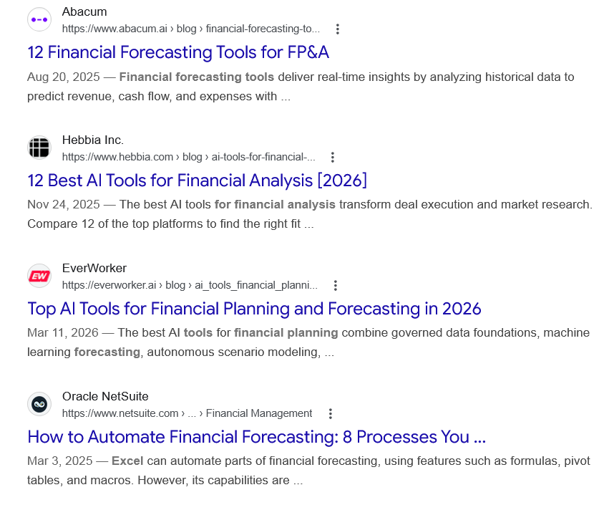
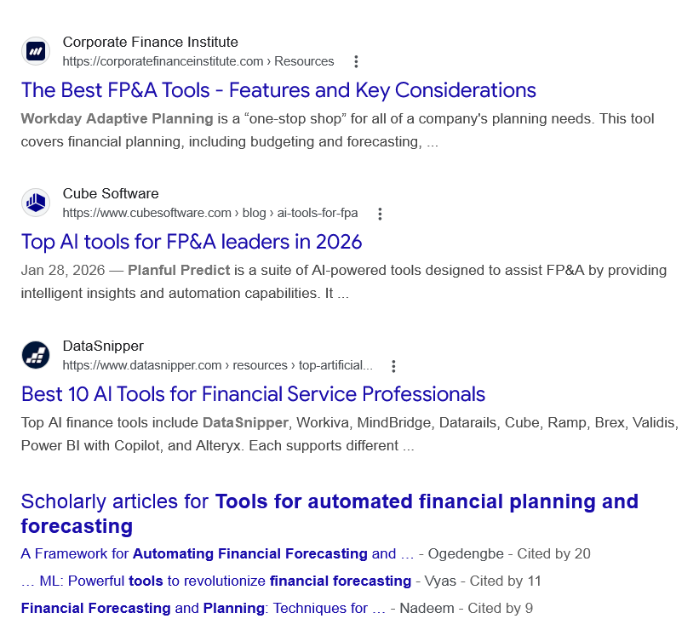
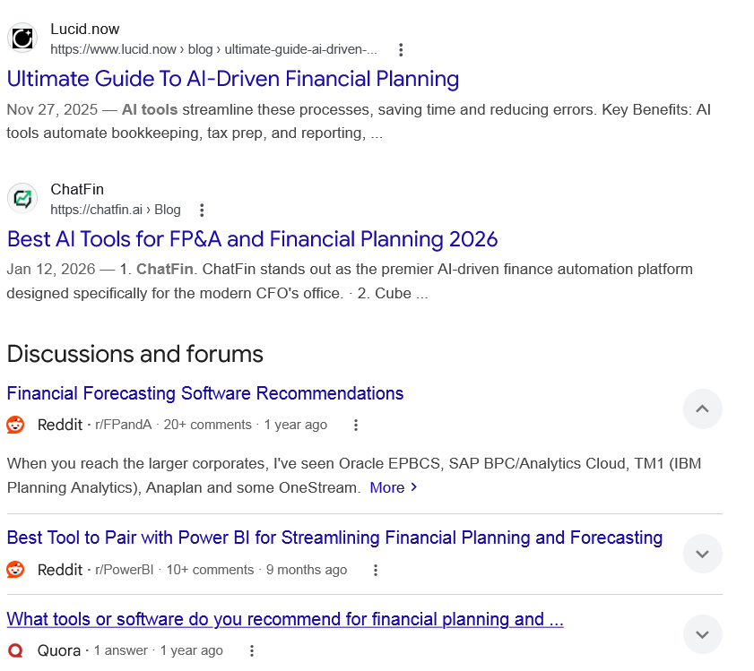

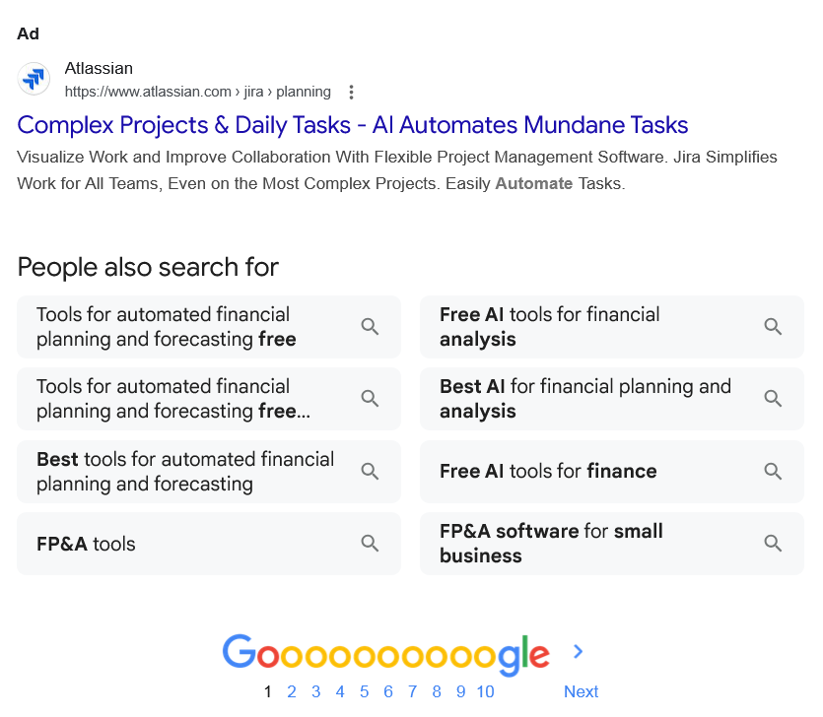

Web results

12 Financial Forecasting Tools for FP&A

Abacum
https://www.abacum.ai › blog › financial-forecasting-to...

Abacum
https://www.abacum.ai › blog › financial-forecasting-to...
Aug 20, 2025 — Financial forecasting tools deliver real-time insights by analyzing historical data to predict revenue, cash flow, and expenses with ...

12 Best AI Tools for Financial Analysis [2026]

Hebbia Inc.
https://www.hebbia.com › blog › ai-tools-for-financial-...

Hebbia Inc.
https://www.hebbia.com › blog › ai-tools-for-financial-...
Nov 24, 2025 — The best AI tools for financial analysis transform deal execution and market research. Compare 12 of the top platforms to find the right fit ...

Top AI Tools for Financial Planning and Forecasting in 2026

EverWorker
https://everworker.ai › blog › ai_tools_financial_planni...

EverWorker
https://everworker.ai › blog › ai_tools_financial_planni...
Mar 11, 2026 — The best AI tools for financial planning combine governed data foundations, machine learning forecasting, autonomous scenario modeling, ...

How to Automate Financial Forecasting: 8 Processes You ...

Oracle NetSuite
https://www.netsuite.com › ... › Financial Management

Oracle NetSuite
https://www.netsuite.com › ... › Financial Management
Mar 3, 2025 — Excel can automate parts of financial forecasting, using features such as formulas, pivot tables, and macros. However, its capabilities are ...

The Best FP&A Tools - Features and Key Considerations

Corporate Finance Institute
https://corporatefinanceinstitute.com › Resources

Corporate Finance Institute
https://corporatefinanceinstitute.com › Resources
Workday Adaptive Planning is a “one-stop shop” for all of a company's planning needs. This tool covers financial planning, including budgeting and forecasting, ...

Top AI tools for FP&A leaders in 2026

Cube Software
https://www.cubesoftware.com › blog › ai-tools-for-fpa

Cube Software
https://www.cubesoftware.com › blog › ai-tools-for-fpa
Jan 28, 2026 — Planful Predict is a suite of AI-powered tools designed to assist FP&A by providing intelligent insights and automation capabilities. It ...

Best 10 AI Tools for Financial Service Professionals

DataSnipper
https://www.datasnipper.com › resources › top-artificial...

DataSnipper
https://www.datasnipper.com › resources › top-artificial...
Top AI finance tools include DataSnipper, Workiva, MindBridge, Datarails, Cube, Ramp, Brex, Validis, Power BI with Copilot, and Alteryx. Each supports different ...

Scholarly articles for Tools for automated financial planning and forecasting
A Framework for Automating Financial Forecasting and … - ‎Ogedengbe - Cited by 20
… ML: Powerful tools to revolutionize financial forecasting - ‎Vyas - Cited by 11
Financial Forecasting and Planning: Techniques for … - ‎Nadeem - Cited by 9

Web results

Ultimate Guide To AI-Driven Financial Planning

Lucid.now
https://www.lucid.now › blog › ultimate-guide-ai-driven-...

Lucid.now
https://www.lucid.now › blog › ultimate-guide-ai-driven-...
Nov 27, 2025 — AI tools streamline these processes, saving time and reducing errors. Key Benefits: AI tools automate bookkeeping, tax prep, and reporting, ...

Best AI Tools for FP&A and Financial Planning 2026

ChatFin
https://chatfin.ai › Blog

ChatFin
https://chatfin.ai › Blog
Jan 12, 2026 — 1. ChatFin. ChatFin stands out as the premier AI-driven finance automation platform designed specifically for the modern CFO's office. · 2. Cube ...
Discussions and forums

Financial Forecasting Software Recommendations
Reddit ·
r/FPandA
· 20+ comments
· 1 year ago

Financial Forecasting Software Recommendations
Reddit ·
r/FPandA
· 20+ comments
· 1 year ago
When you reach the larger corporates, I've seen Oracle EPBCS, SAP BPC/Analytics Cloud, TM1 (IBM Planning Analytics), Anaplan and some OneStream. More

Best Tool to Pair with Power BI for Streamlining Financial Planning and Forecasting
Reddit ·
r/PowerBI
· 10+ comments
· 9 months ago

Best Tool to Pair with Power BI for Streamlining Financial Planning and Forecasting
Reddit ·
r/PowerBI
· 10+ comments
· 9 months ago
Best Tool to Pair with Power BI for Streamlining Financial Planning and Forecasting ... The key was automating the data side so our models ... More

What tools or software do you recommend for financial planning and ...
Quora ·
1 answer
· 1 year ago

What tools or software do you recommend for financial planning and ...
Quora ·
1 answer
· 1 year ago
MS Excel for financial modeling and R for time series forecasting. Many of my colleagues use some combination of these two, Stata and/or Eviews. More

See more

Ad

Complex Projects & Daily Tasks - AI Automates Mundane Tasks

Atlassian
https://www.atlassian.com › jira › planning

Atlassian
https://www.atlassian.com › jira › planning

My Ad Centre
Visualize Work and Improve Collaboration With Flexible Project Management Software. Jira Simplifies Work for All Teams, Even on the Most Complex Projects. Easily Automate Tasks.
People also search for

Tools for automated financial planning and forecasting free

Tools for automated financial planning and forecasting free download

Best tools for automated financial planning and forecasting

FP&A tools

Free AI tools for financial analysis

Best AI for financial planning and analysis

Free AI tools for finance

FP&A software for small business

